Experiment No – 12
Title / Aim :- Build an interactive real-time web app using JavaScript and jQuery with DOM, events, storage, and AJAX integration.
Software/Tools Required :-
- Visual Studio Code (VS Code)
- Google Chrome / Any Web Browser
- HTML
- JavaScript
Theory : -
JavaScript is a client-side scripting language used to develop dynamic and interactive web applications. It allows developers to manipulate the Document Object Model (DOM), handle user events, validate forms, and update webpage content without reloading the page. jQuery is a JavaScript library that simplifies DOM manipulation, event handling, and AJAX operations. In this project, jQuery is used to dynamically generate event cards, handle registration and cancellation buttons, and update seat availability.
AJAX (Asynchronous JavaScript and XML) is used to retrieve event information from the events.json file without refreshing the webpage. JSON (JavaScript Object Notation) stores structured event details such as event name, date, venue, and seating capacity. Local Storage is used to save registration details in the browser so that the data remains available after refreshing the page. Form validation ensures correct user input, while JavaScript dynamically calculates total events, booked seats, and available seats. Thus, the project combines DOM manipulation, events, jQuery, AJAX, JSON, and browser storage to create an interactive event registration system.
Output
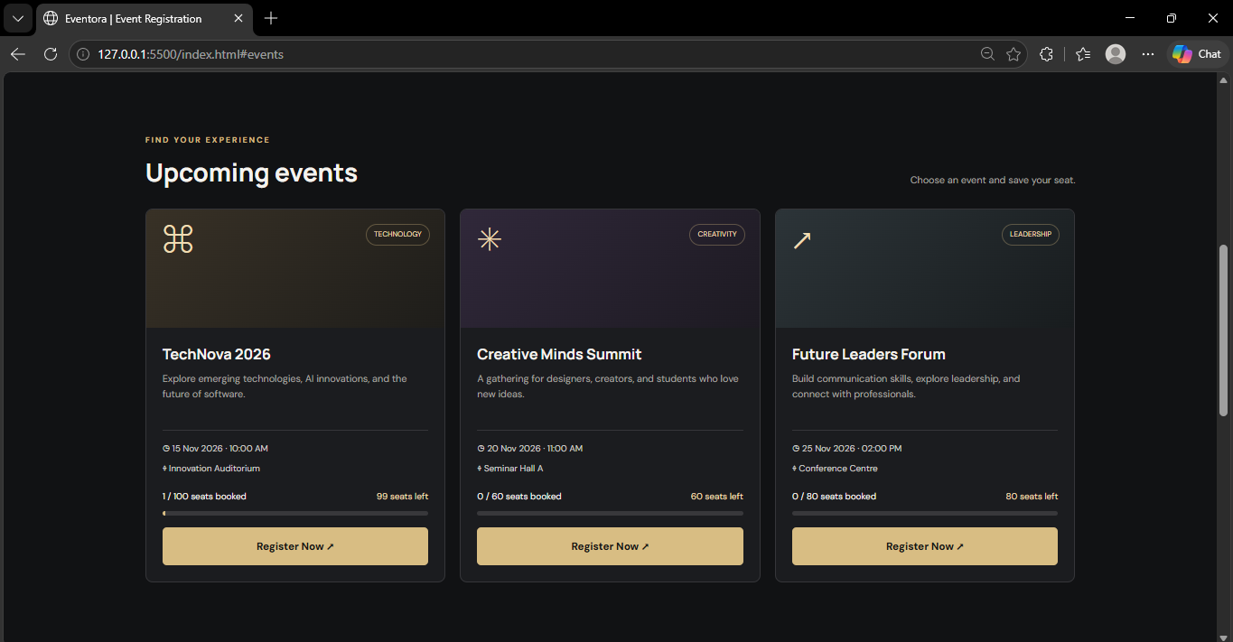

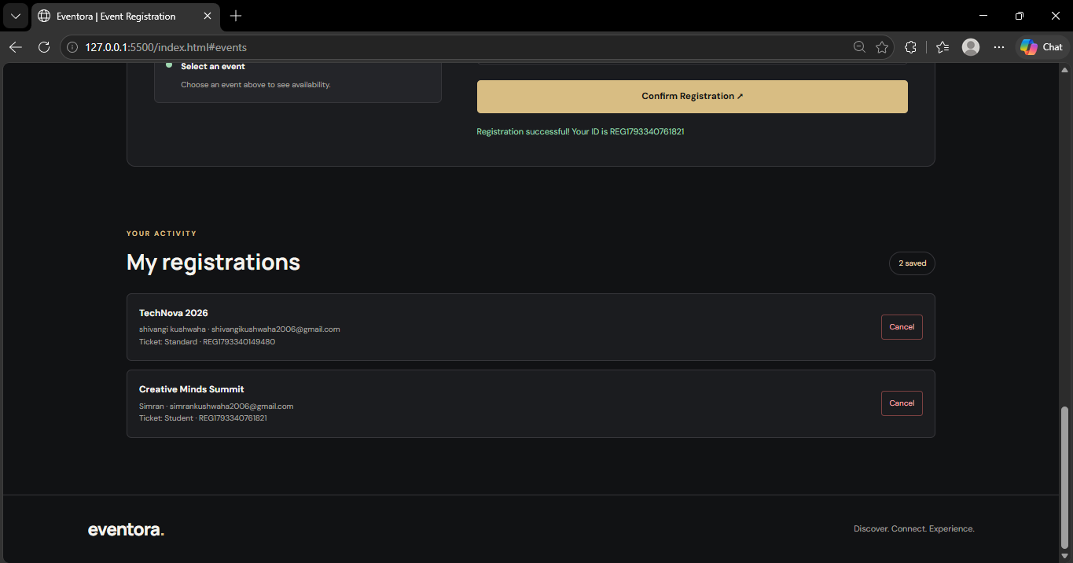

Result / Conclusion :-
Successfully developed an interactive Eventora Event Registration Website using HTML, CSS, JavaScript, and jQuery. The website dynamically fetches event details from a JSON file using AJAX and displays them as event cards. It provides user registration, form validation, booking cancellation, and Local Storage functionality. Seat availability and dashboard statistics update automatically whenever a registration is added or cancelled. Hence, the experiment demonstrates the practical implementation of DOM manipulation, event handling, AJAX, JSON, and browser storage in a real-time web application.

